1000-1136 Isolation and Cryopreservation of PBMCs – ITN

Purpose:
This document provides the procedure for the isolation and cryopreservation of peripheral blood mononuclear cells (PBMC) from whole blood samples using Ficoll-Paque PLUSTM density gradient centrifugation.
Scope:
This procedure applies to Lab Services personnel in the ITN Biorepository facility when isolating PBMC from up to 300mL whole blood with subsequent storage for ITN.
A. Definitions:
Term | Description
DMSO | Dimethyl Sulfoxide
DPBS | Dulbecco’s Phosphate Buffered Saline
PBMC | Peripheral Blood Mononuclear Cells
RBC | Red blood cell
RCF(g) | Relative Centrifugal Force (g-force)
RT | Room Temperature (18-25°C)
HuAB | Human AB serum

C. Roles and Responsibilities:
Role | Responsibility
Lab technician | Responsible for performing all steps of procedure and documentation as well as ensuring all equipment is up to date and functioning correctly.
Lab management | Same responsibilities as technicians and to ensure acceptance criteria are met. Report deviations to Project Management or client.  Assist with troubleshooting as required.
D. Equipment/Materials Required:
Number | Equipment/Material Description
N/A | Biosafety cabinet
Eppendorf, 5810 5810R, or equivalent | Centrifuge for tubes with horizontal rotor
N/A | Centrifuge buckets with adapters for 50mL conical tubes and 15mL conical tubes
ChemoMetec A/S | NucleoCounter NC-200
ChemoMetec A/S, 941-0012 | Via1-Cassette
N/A | LN2-safe cryovials for PBMC aliquots
N/A | 250mL plastic container, sterile
N/A | 50mL conical tubes, sterile
N/A | 15mL conical tubes, sterile
N/A | 1.5mL microcentrifuge tubes
N/A | Serological pipettes graduated 5mL, 10mL, 25mL, 50mL
N/A | 100-1000µL sterile, filtered, pipette tips, normal and wide bore
N/A | 20-200µL sterile, filtered, pipette tips, normal and wide bore
Gilson, Pipetman, Rainin | Manual pipettes, suitable to volumes being transferred
N/A | Pipette aid
N/A | Ficoll-Paque PLUS
N/A | 1X Dulbecco’s PBS sterile, Ca++, Mg++ Free
N/A | 1X RPMI 1640, with L-glutamine
N/A | DMSO, Sterile
N/A | HuAB
N/A | Mr Frosty, CoolCell, or equivalent, or controlled rate freezer

Specific content in this procedure is identified as follows:

 | Safety – Precautions or safety issues associated with the entire SOP or with a particular step.
 | Radioactive – Radioactive samples.
 | Sample Integrity – Handle samples with care to avoid compromising the integrity.
 | Scan – Scan the barcode.
 | Verify – Verify a task per the stated attributes.
 | If, then – Contingency instructions.
 | Information – Information used for the execution of the associated step.

General Information

 | Use caution when handling DMSO and media containing DMSO.
 | All reagents and consumables must be sterile and must only be opened in the Biosafety Cabinet to maintain sterility.
 | HuAB will be provided by the client. Use only HuAB provided by the client for ITN PBMC processing. Record lot number and expiration date. Record freeze/thaw on  aliquots of HuAB and do not thaw more than 5 times.

E. Procedure

- Pre-Processing

Step | Instruction | Example
1.1. |  All steps MUST be performed in the Biosafety Cabinet.
1.2.
1.3. | Label the first page with the processing date, Subject ID or OIDs, ITN Study Name, and Collection Date/Time from requisition form.  Ensure the Processing date and Subject ID are also recorded.   Use one Subject Record per subject received on a given day if pooling is performed. Record all Registration numbers.  If sample is >5 days past collection date/time at the start of processing then initiate a discrepancy and DO NOT PROCESS the samples. Discard per normal lab procedures.
1.4. | Complete the Reagent Log with the corresponding reagent lot number(s) and expiration date(s) for all reagents used on the day of processing.
1.5. | Record the processing start time.
1.6. | Visually inspect all whole blood tubes for each subject. Note any irregularities.

- Undiluted Plasma Collection

Step | Instruction | Example
2.1. | Verify that plasma isolation is required.  If plasma isolation is not required, proceed to section 3

Step | Instruction | Example
2.2. | Verify each subject is separately identified.  If pooling multiple sample vials for one subject, confirm all data is identical for each vial to be pooled together:  If total blood volume is <5mL, use a 15mL conical tube.  If total blood volume is between 5mL and 35mL, use a 50mL conical tube. If total blood volume is >50mL, use a 250mL flask  If total blood volume is >120mL, use multiple flasks.  If only one vacutainer is received, transfer the blood to a 15 mL conical tube if the volume is less than 5 mL, or to a 50 mL conical tube if the volume is greater than 5 mL.
2.3. | Prepare the required number of conical tubes/flask and label with the appropriate identifying information for each subject received.  Each conical tube shall be labeled with the subject number and the following designation: “WB” (whole blood), “P” (plasma), and “T” (total).   After whole blood collection, record the collected volume on the conical tube  adjacent to the “WB” designation. After plasma collection, record the collected volume on the conical tube adjacent to the “P” designation.
2.4. | Record the total blood volume and any observations for the subject.
2.5. | Place conical tubes with whole blood in appropriate centrifuge buckets and balance them. Centrifuge at 650 x g for 10 minutes with an acceleration setting of 9 and a brake setting of 3.
2.6. | Remove the tubes carefully without disturbing the separation layers.  If the sample does not fractionate: immediately contact lab management and PM, then initiate a discrepancy. | 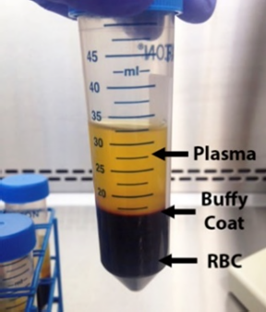
2.7. | Record plasma observations.   Plasma observations should be documented as Normal, Hemolyzed, or Lipemic.
2.8. | If multiple conical tubes from a single subject were centrifuged to obtain plasma, pool all plasma layers into one appropriately labeled conical tube prior to preparing individual plasma aliquots. Store the aliquot vials at 5 °C until labels are generated.
2.9. | Print custom plasma labels. Apply the labels to sterile cryovials.

Step | Instruction | Example
2.10. | Aliquot the plasma into the labeled cryovials and store at 5 °C until same-day processing is complete.  When processing is complete, transfer plasma aliquots to −80 °C storage.  Record the total number of plasma aliquots created.
2.11. | Record the volume of plasma removed.
2.12. | Replace the removed volume with an equal volume of 1X DPBS in the conical tube containing the buffy coat and RBCs.  Gently pipette up and down three (3) times to resuspend. Document volume of 1X DPBS added.

- PBMC Isolation from Whole Blood Using Ficoll-Paque PLUS density gradient centrifugation

Step | Instruction | Example
3.1. | Verify each subject is separately identified. If pooling multiple sample vials, for one subject, confirm all data is identical for each vial to be pooled together.
3.2. | Identify if a 15 mL, 50mL conical or larger vessel will be needed.  If total blood volume is <5mL, use a 15mL conical tube  If total blood volume is between 5mL and 35mL, use a 50mL conical tube. If total blood volume is >50mL, use a 250mL flask  If total blood volume is >120mL, use multiple flasks.  If only one vacutainer is received, transfer the blood to a 15 mL conical tube if the volume is less than 5 mL, or to a 50 mL conical tube if the volume is greater than 5 mL.
3.3. | Prepare the required number of conical tubes/flask and label with the appropriate identifying information for each subject received.  Each conical tube shall be labeled with the subject number and the following designation: “WB” (whole blood), “P” (plasma), and “T” (total).   After whole blood collection, record the collected volume on the conical tube adjacent to the “WB” designation. After plasma collection, record the collected volume on the conical tube adjacent to the “P” designation.
3.4. | Combine all vials from one subject into the appropriately labeled plastic container via aseptic pouring. Measure the whole blood volume using a serological pipette.  Record the total blood volume and any observations.

Step | Instruction | Example
3.5. | Dilute the pooled blood using an equal amount of 1X DPBS (RT) using a serological pipette.  Mix gently by pipetting up and down against the inner wall of the flask, at least 3 times.  Record the volume of 1X DPBS added to the whole blood.  Record the total volume of diluted blood. | 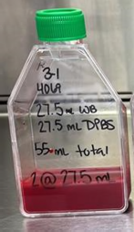
3.6. | Calculate the number of Ficoll-Paque PLUSTM tubes required to layer all diluted blood.  If using 50 mL conical tube, divide the total volume of diluted blood by 30 and round up to the nearest whole number.  If using 15 mL conical tube, divide the total volume of diluted blood by 10 and round up to the nearest whole number.  Record the number and size of Ficoll-Paque PLUSTM tubes needed.
3.7. | Label each Ficoll-Paque PLUSTM tube with the sample identifier.   Up to 35mL of diluted blood can be layered into 1 Ficoll-Paque PLUSTM tube.  If the total volume of diluted blood is less than 10mL, then only one 15mL conical tube will be required.
3.8. | Prepare Ficoll-Paque PLUSTM tubes:  - Remove Ficoll-Paque PLUS™ from 5 °C storage and allow it to equilibrate to room temperature.  - For 15 mL conical tubes, pipette 5 mL of Ficoll-Paque PLUS™ into each tube, avoiding contact with the inner walls.  - For 50 mL conical tubes, pipette 15 mL of Ficoll-Paque PLUS™ into each tube, avoiding contact with the inner walls.

Step | Instruction | Example
3.9. | For 50mL conical tubes, gently layer up to 35 mL of diluted blood onto the dispensed Ficoll-Paque PLUSTM tube.  For 15mL conical tubes, gently layer up to 10mL of diluted blood onto the dispensed Ficoll-Paque PLUSTMTM tube  Layer blood by placing the serological tip to the inside of the conical tube and slowly dispense to minimize the mixing of the 2 phases.   RBC may start to settle prior to centrifugation. This is expected. | 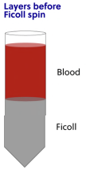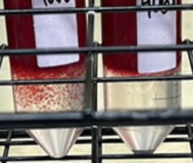
3.10. | Place the conical tubes containing layered, diluted blood into the appropriate centrifuge buckets and ensure they are balanced.  Centrifuge at 650 × g for 30 minutes with an acceleration setting of 9 and a brake setting of 0.
3.11. | Carefully remove the tubes from the centrifuge without disturbing the separation layers. Record observations of cell layers.   Depending on sample quality and centrifugation performance, the resulting cell layer may appear as white, red, white with red, or red with white.   RBC contamination should be noted at this step.  If the tubes do not have clearly defined separation layers, then improper separation may have occurred. | 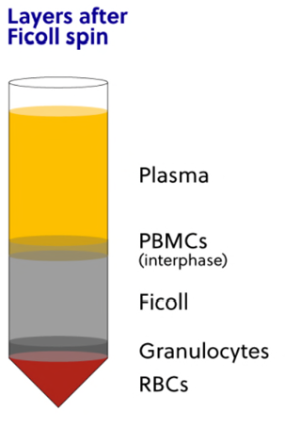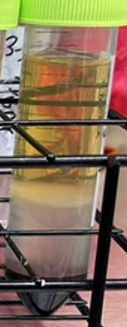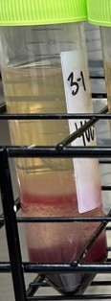
3.12. | Prepare new, labeled conical tubes of the same size as previously used, including the appropriate subject identifiers.   Prepare one new conical tube for every two Ficoll-Paque PLUS™ tubes per subject.

HuAB Washing Solution
HuAB, RT | 1X dPBS, RT
500 µL | 49.5 mL

Step | Instruction | Example
3.13. | Using a serological pipette, carefully remove and discard the top half of the diluted plasma layer, leaving approximately 1 cm above the cell layer.  Dispose of the removed plasma into a properly labeled biohazard waste container.
3.14. | Collect the PBMCs from the diluted plasma/Ficoll-Paque PLUSTM interface using a new serological pipette tip. Dispense into the newly prepared conical tube.   Interface cells from two 50 mL tubes can be combined into one wash tube, as needed.  While collecting the cells, be sure to aspirate as little Ficoll-Paque PLUS™ as possible (<5 mL). Lower cell numbers will pellet if the proportion of Ficoll-Paque PLUS™ is too high in the wash tube as it is toxic to the cells.
3.15. | Add enough 1X DPBS (RT) to bring the total volume of each tube to 90% of the total tube capacity. Secure the lid and gently invert at least 3 times to mix.  Record the total number of conical tubes after pooling PBMCs.
3.16. | Centrifuge conical tube(s) at 360 x g 10 minutes with an acceleration setting of 9  and a brake setting of 3.
3.17. | Prepare enough 1% HuAB washing solution in a new, sterile container.   50mL of 1% HUAB Washing Solution is enough for 5 subject samples.
3.18. | Carefully remove the tubes from the centrifuge without disturbing the pellet and record observations.   Depending on sample quality and centrifugation performance, the resulting cell layer may appear as white, red, white with red, or red with white. | 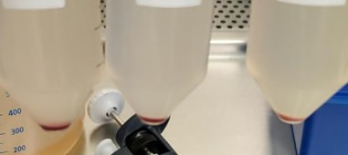
3.19. | Discard the supernatant from each tube without disturbing the pellet  If the pellet is soft, aspirate the supernatant using a sterile serological pipette and discard it into an appropriately labelled biohazard waste container.  If the pellet is small and hard, the supernatant can be gently poured off into an appropriately labelled biohazard waste container.  Do not allow cells to remain pelleted for more than a couple minutes. Immediately resuspend cells following supernatant removal to maintain cell viability.

Step | Instruction | Example
3.20. | For hard pellet, gently add 5 mL of sterile 1% HuAB washing solution over the cell pellet by placing the pipette tip on the inner wall of the conical tube.  For soft/loose pellet, gently add 1% HuAB washing solution up to the 5ml mark on the conical tube by placing the pipette tip on the inner wall of the conical tube.  Mix by gently pipetting up and down.  Do not directly pipette onto the cell pellet as this can cause cell damage and lower cell counts.
3.21. | If multiple pellets are present for a single subject, resuspend each pellet and transfer the resulting cell suspension into a single sterile, labeled 50 mL conical tube. Repeat until all pellets for the subject have been resuspended and combined.
3.22. | Calculate the volume of 1% HuAB washing solution required to bring the final volume to 10 mL. Add the calculated volume of washing solution to the original tubes to rinse and collect any remaining cells, then transfer the rinses to the pooled cell suspension.  Gently mix to ensure a uniform suspension.  If the cell pellet is large, the final resuspension volume may be increased to 20 mL or 30 mL, as appropriate.  Record the final cell suspension volume.
3.23. | Transfer 50µL of each sample to a clean, labeled 1.5mL microcentrifuge tube containing 150uL of counting medium for automated cell counting.  Perform cell counting using 4-fold dilution. Document dilution.  If improper separation was previously noted, the sample should also be analyzed at a dilution factor of 20.  If the sample is low volume and was layered on 5 mL of Ficoll-Paque PLUS™, the sample should also be analyzed at a dilution factor of 2 (100µL of cells to 100µL of cell counting media).
3.24. | Add 5 mL of sterile 1% HuAB washing solution to resuspend cells. Mix by gently pipetting up and down  Centrifuge conical tube(s) at 360 x g 10 minutes with an acceleration setting of 9  and a brake setting of 3.

Step | Instruction | Example
3.25. | Store cell suspension at 4°C until counting is completed.
- Cell Counting

Step | Instruction | Example
4.1. | Record the Total cells/mL, Viables cells/mL, and Viability % straight from the automated cell counter read out.
4.3. | Calculate the total viable cells in the cell suspension. Use the volume of cell suspension from step 3.22. in the calculation.. | x =  Total Cell Total Cells  cells/mL suspension final volume mL  x = Viable Volume of Total Viable cells/mL cell Cells  suspension
4.4. | Determine the volume of Freezing Media required for each cell suspension to meet the requested concentration. | / =  Total Total  Viable Requested volume  Cells Concentration freezing  media
4.5. |   HuAB will be used to resuspend the cell pellet.  Calculate the volume of HuAB to be used. | x 0.5 =  Total volume HuAB to add to  freezing media cell pellet
4.6. | Prepare 20% DMSO, 80% HuAB at equal volume to HuAB calculated in previous step.   20% DMSO, 80% HuAB may be prepared in a larger batch to accommodate for all samples received in a single day. | 20% DMSO DMSO HuAB  80% HuAB  1 mL 200 µL 800 µL  5 mL 1 mL 4 mL  15mL 3 mL 12 mL  20 mL 4 mL 16 mL
4.7. | Remove all tubes with cell suspension from the 4°C and centrifuge 300 x g for 10 min with an acceleration setting of 9 and a brake setting of 3.

Step | Instruction | Example
4.8. | Carefully remove and discard the supernatant from each tube without touching the pellet. This can be accomplished with a serological pipette or by gently pouring the supernatant off.  Do not let cells sit in the pellet for a prolonged time (more than a minute) as pelleted cells start dying if not resuspended immediately.  If the pellet is loose and red, leave behind 5 mL of HuAB.
4.9. | Resuspend the cell pellet in the volume of HuAB previously calculated in step 4.5.  If the pellet is loose and red, subtract pellet volume from the HuAB volume being added in order to not exceed the calculated total volume.
4.10. | Slowly add 20% DMSO, 80% HuAB to the cell suspension at a volume equal to that in step 4.9 in a dropwise manner. Gently mix by pipetting, taking care to avoid bubble formation.   The final Freezing Media concentration is a 10% DMSO solution.
4.11. | Record the number and volume of PBMC aliquots.
4.12. | Observe that there is liquid biomaterial in each aliquot. Place aliquots in CoolCell container(s) at RT (or equivalent controlled freezing container).
4.13. | Move CoolCell container(s) to -80°C storage environment for at least 24 hours but not more than 48 hours. Record the time the CoolCell (or equivalent) was placed into the -80C storage environment.  Aliquots must be moved to LN2 (-190°C) within the 24-48 hour timeframe.

- PBMC Post-Processing

Step | Instruction | Example
5.1. | Update any additional processing comments if necessary.
5.2. | Ensure all PBMC aliquots are stored at the long-term storage temperature. Dispose consumed parent tubes using standard lab disposal process.
5.3. | For any deviations from procedure or problems with sample integrity, the manager or supervisor must be notified.

